Dr. Nabila Hanosh
Belsize Priory Medical Practice
208 Belsize Road
London NW6 4DX
T: 020 7328 8200
F: 020 7372 6138

E: reception.bpmp@nhs.net
W: www.belsizepriorymedicalpractice.co.uk

10th May 2022

Dear Patient,

Your views on the relocation of Belsize Priory Medical Practice to The Abbey Road Centre, 172A Belsize Road, London, NW6 4BJ.

We are writing to you as a patient registered with the practice to inform you of a change of location of our GP surgery. Although the surgery has been located at its present site for many years, the current premises will be demolished as part of the Abbey Road Re-development, which is to be completed by July 2022, date will be confirmed nearer to the time of move.

Frequently Asked Questions

Why does the surgery have to move?

In 2013, The Abbey Road development centred on the junction of Abbey Road and Belsize Road was approved by Camden Council. The development was planned in three phases:
- Phase 1: 141 new homes completed in March 2019
- Phase 2: building a new two storey health and community services centre, open spaces, car parking, and road layout changes (currently underway due for completion in July 2022)
- Phase 3: the existing health centre site will be demolished, replaced with housing and the project completed.

How do you get there from Belsize Priory Medical Practice’s current building?

The new site is within easy reach of the current surgery and is approximately within 100 meters (0.06 miles) walk from our current building. The new surgery is accessible by public transport Buses 31, 139 and 189.

From July 2022, the Belsize Priory Medical Practice, will need to move from the current site to the purpose built health centre at 172A Belsize Road, London, NW6 4BJ

Map of distance between both sites

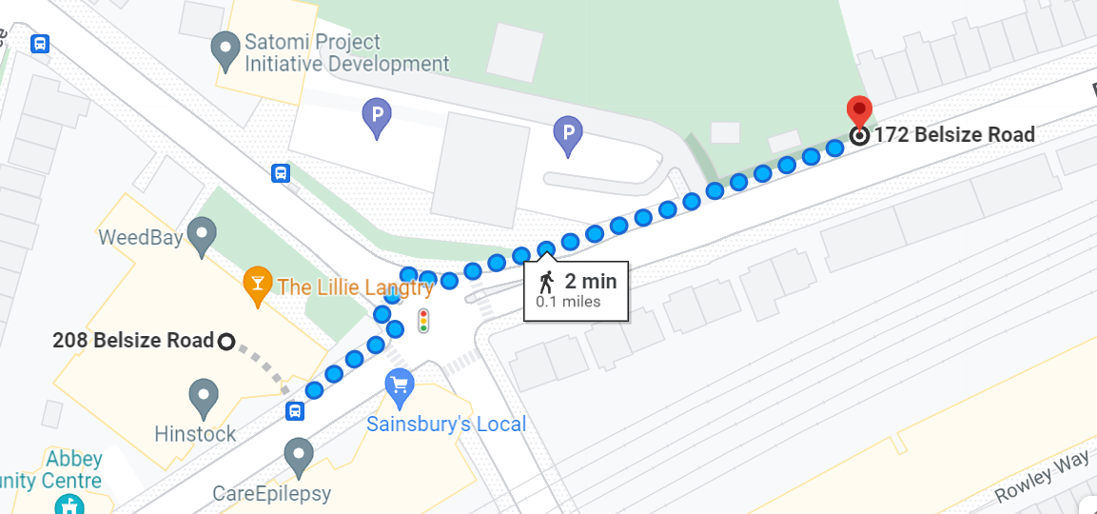

What does this mean for patients?

You do not need to do anything and you will continue to be registered with the Belsize Priory Medical Practice – no patients will be asked to leave as a result of the relocation.

All the staff, clinical and reception staff will continue to work at the practice and there will be no change to our practice opening hours. The surgery telephone number will remain the same.

We understand this proposal might affect some people more than others; so before any final decisions are made we would like to hear your views, recommendations and any potential challenges this relocation might mean for you.

How can I share my thoughts?

- Use the link in this letter to complete the patient survey online:
https://feedback.camdenccg.nhs.uk/gp-practice/relocation-of-belsize-priory-medical-practice-to-a or
- Alternatively, you can pick up a paper survey when you are in the practice.

The deadline to complete and return your survey is the 7 June 2022. If you need any help to complete this survey, you can call the surgery on 020 7328 8200 and a member of the team will go through it with you. Forms are also available within the surgery for you to complete.

What do you need to do next?

You can continue to access your GP in the usual way.

The feedback we receive from you will form part of the CCG application to relocate the surgery and we will contact you again once a decision has been made and to share what the next steps will be.

If you have any queries, comments, or concerns please feel free to contact the practice on the contact details below.

Yours sincerely

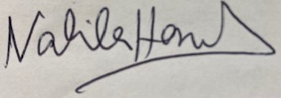
Dr Nabila Hanosh

If you require this in another format, such as large print,
easy-read, braille, audio, or another language, please contact reception.bpmp@nhs.net

