CHILD’S REGISTRATIONS

Belsize Priory Medical Practice
208 Belsize Road
London NW6 4DX
0207 328 8200
E-mail: reception.bpmp@nhs.net
www.belsizepriorymedicalpractice.co.uk

You can apply to register whether you live in or out of the practice catchment area
GP practices now have the option to register patients who live outside the practice area but without any obligation to provide home visits.
Out of area registration (with or without home visits) is voluntary for GP practices meaning patients may be refused because they live out of area.
Your application will be considered by the practice and will only register you without home visits if it is clinically appropriate and practical in your individual case.

When registering this is what we require from you:

→ Carers Passport/ Driving Licence (proof of your identification)
If baby/child has a birth certificate, please also bring this in as proof.
→ 2 proofs of carers address to go along side baby/child’s

→ Child’s RED BOOK (Immunisation Records) for age 6 weeks - 6Years Old

Application Forms need to be completed in full.
If you don’t understand anything, please ask a receptionist who will be
pleased to help.

ZERO TOLERANCE

The practice pledges to treat all patients with dignity and respect.
Our staff have the right to be treated with dignity and respect in the same way.
We will NOT tolerate violence in any form, physical or verbal towards our Staff.

Office use only: 2 Proofs of Address □ Leaflet given □

Carers ID □ Red book □

Checked by ________ Registered by ________ Date: ____________ Emis_______

REFUGEE: TICK BOX FOR YES

Surname’s
First Name’s
Date and place of birth
Home Address
Telephone number

Ethnic Category:
White | Mixed | Asian and British Asian | Black/British Black | Other
British | White and Black Caribbean | Indian | Caribbean | Chinese
Irish | White and Black African | Pakistani | African | Other
Other Please State Below | White and Asian | Bangladeshi | Other Please state below
 | Other Mix | Other

Main Language:
Height(cm)
Weight(Kg)

Interpreter: Yes No

Allergies:

- Carer of Patient a.) Name ________________________
b.) Telephone Number: ________________________

3. Child’s Day Care: ________________________________________________

4. If your child has any disabilities, please give us details: ______________________________________

5. Does anybody in the child’s family suffer from any of the listed disease.
Disease | Relationship To You
Cancer / please specify
Stroke
Asthma
Heart Disease
Diabetes
Epilepsy
High Blood Pressure
Thyroid Disorder
Mental Problem
Bronchitis, Emphysema
Eczema

6. Please Give us the Name & Address of your Childs School:

Name & Address of School
School Telephone Number

7. Child immunisation update, if child has had any of these vaccines
Please complete the following:
Vaccinations | Place Of Procedure | Date
1st DTP & Polio Vac/HIB (2 month old)
1st Pneumococcal (PCV) (2 month old)
2nd DTP/PV/HIB (3 month old)
1st Meningitis C Vac. (3 month old)
3rd DTP & Polio Vac/ HIB (4 month old)
2nd Meningitis C Vac. (4 month old)
2nd Pneumococcal (PCV) (4 month old)
HIB/ Meningitis C Vac (around12 month)
1st Measles/Mumps/Rubella Vac (MMR) (around13month)
3rd Pneumococcal (PCV) (around 13 month)
4th DTP/PV/HIB Booster (3-4 years)
2nd Measles/Mumps/Rubella Vac (MMR) Preschool booster
(3-4 years)

- Please state name of parent/guardian on the birth certificate.
Name and signature:
Relationship To Patient:
Email address:
Telephone Number:

To be completed if you have specific communication needs

Communication Support

If you struggle to complete this form, please ask a member of staff to help you.

Do you consent for this information to be shared with other health & social care organisations?
Yes [ ] No [ ]

Are you visual Impaired? Yes [ ] No [ ]
Would you benefit from any of the following: Braille [ ] Large Print [ ] Audio tape [ ]
(please note that our system doesn’t allow this at present, however, capturing the information will help us plan future developments)

Deafness: Yes [ ] No [ ] Other…………………………………………………………………………………

If you have a difficulty communicating, which is your preferred method of communication.
Home tel number [ ] letter to home address [ ]
Work tel number [ ] letter to temporary address [ ]
Mobile tel number [ ] Fax [ ]
Email address [ ] video conference* [ ]
(*please note that our system doesn’t allow this at present, however, capturing the information will help us plan future developments)
Do you have any other communication need we should know about? Please Describe?

Name………………………………….…………………………………

Date of Birth:……/…………./……………

Please note: The information you give will be treated confidentially and is subject to the
Data Protection Act.

Your emergency care summary

What is the Summary Care Record?
It is NHS centrally held electronic record which contains:
- Your recent and current Medication (from last 12 months)
- Allergies you suffer from
- Any Adverse Reactions to Medicines you have had.

Why do I need a Summary Care Record?
Summary Care Records are being introduced to improve the safety and quality of patient care. Because the Summary Care Record is an electronic record, it will give healthcare staff faster, easier access to essential information about you, and help to give you safe treatment during an emergency, when admitted to hospital or when your GP surgery is closed.
For example, a person who lives in London is on holiday in Brighton. One evening, they're knocked unconscious in a car accident and taken to an accident and emergency (A&E) department. Under the current system of storing health records, it would be difficult for A&E staff to find out whether there are any important factors to consider when treating the person (such as any serious allergies to medications), especially as their GP surgery is likely to be closed. If healthcare staff cannot get the relevant health information quickly, some patients may be at risk.
A Summary Care Record is an electronic record that's stored at a central location. As the name suggests, the record will not contain any other information about your medical history. It will only contain: your last 12 months’ medication, your allergies and adverse reactions to medicines.

Who can see it?
Access to your Summary Care Record will be strictly controlled. The only people who can see the information will be healthcare staff directly involved in your care who have a special smartcard and access number (like a chip-and-pin credit card).
Healthcare staff will ask your permission every time they need to look at your Summary Care Record. If they cannot ask you, e.g. because your unconscious, healthcare staff may look at your record without asking you. If they have to do this, a record will be made.

How do I know if I have one?
Summary Care Records are now in Camden and all patients will have a summary care record created, and it will include just their medications (last 12m), allergies and adverse reactions to medicines.

Do I have to have one?

No, if you choose not to have one, then you will need to complete a form and bring it along to the surgery. You can download a form, or obtain one from your surgery. You can change your mind at any time – just tell your Practice.

More Information For further information visit www.nhscarerecords.nhs.uk or call the information line on 0300 123 3020

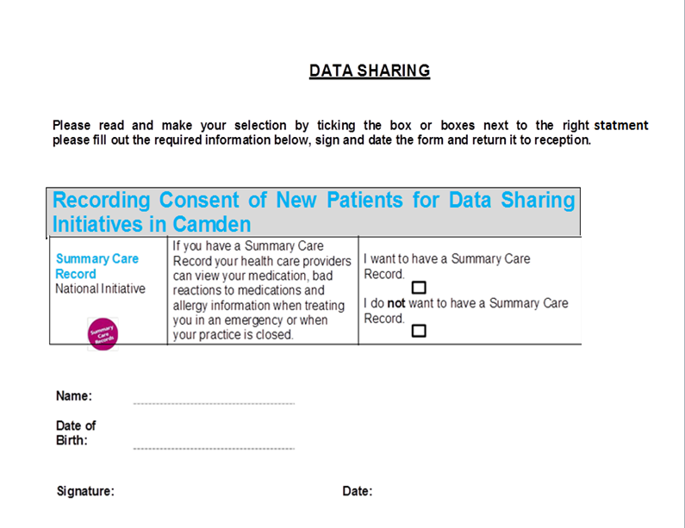



HEALTH INFORMATION EXCHANGE
We are joining up your health and care records to improve the local services you receive. What does this mean for you?

Being able to see your health and social care records at any time and in different places means health and care professionals can make quicker and safer decisions about your care

Health and care professionals have shared information on paper for many years – we now plan to do this using digital technology.

GP practices and other health and care organisations are joining up the electronic records of all adults and children across Barnet, Camden, Islington, Enfield and Haringey (north central London) so that those delivering care can understand all your needs and make the best decisions about your care with you.

You have a choice

If you are happy for your information to be part of the joined-up health and care records, you don’t need to do anything. However, if you don’t want to be included and you choose to opt-out, your information will not be available via electronic joined-up records, however it will continue to be shared by care organisings as it is now, by phone, email and on paper.
If you choose to opt out, you will not be able to take advantage of the benefits that electronic joined-up records can bring you.

The care professionals looking after you won’t have your full history and most recent information available to them, even in emergency situations. Opting out will also make it harder for health and care professionals to proactively plan and manage your care and support your wellbeing.
You have a choice

If you are happy for your information to be part of the joined-up health and care records, you don’t need to do anything. However, if you don’t want to be included and you choose to opt-out, your information will not be available via electronic joined-up records, however it will continue to be shared by care organisings as it is now, by phone, email and on paper.

If you choose to opt out, you will not be able to take advantage of the benefits that electronic joined-up records can bring you.

The care professionals looking after you won’t have your full history and most recent information available to them, even in emergency situations. Opting out will also make it harder for health and care professionals to proactively plan and manage your care and support your wellbeing.

You have a choice

If you are happy for your information to be part of the joined-up health and care records, you don’t need to do anything. However, if you don’t want to be included and you choose to opt-out, your information will not be available via electronic joined-up records, however it will continue to be shared by care organisings as it is now, by phone, email and on paper.
If you choose to opt out, you will not be able to take advantage of the benefits that electronic joined-up records can bring you.

The care professionals looking after you won’t have your full history and most recent information available to them, even in emergency situations. Opting out will also make it harder for health and care professionals to proactively plan and manage your care and support your wellbeing.
You have a choice

If you are happy for your information to be part of the joined-up health and care records, you don’t need to do anything. However, if you don’t want to be included and you choose to opt-out, your information will not be available via electronic joined-up records, however it will continue to be shared by care organisings as it is now, by phone, email and on paper.
If you choose to opt out, you will not be able to take advantage of the benefits that electronic joined-up records can bring you.

The care professionals looking after you won’t have your full history and most recent information available to them, even in emergency situations. Opting out will also make it harder for health and care professionals to proactively plan and manage your care and support your wellbeing.
You have a choice

If you are happy for your information to be part of the joined-up health and care records, you don’t need to do anything. However, if you don’t want to be included and you choose to opt-out, your information will not be available via electronic joined-up records, however it will continue to be shared by care organisings as it is now, by phone, email and on paper.
If you choose to opt out, you will not be able to take advantage of the benefits that electronic joined-up records can bring you.

The care professionals looking after you won’t have your full history and most recent information available to them, even in emergency situations. Opting out will also make it harder for health and care professionals to proactively plan and manage your care and support your wellbeing.

You have a choice

If you are happy for your information to be part of the joined-up health and care records, you don’t need to do anything. However, if you don’t want to be included and you choose to opt-out, your information will not be available via electronic joined-up records, however it will continue to be shared by care organisings as it is now, by phone, email and on paper.
If you choose to opt out, you will not be able to take advantage of the benefits that electronic joined-up records can bring you.

The care professionals looking after you won’t have your full history and most recent information available to them, even in emergency situations. Opting out will also make it harder for health and care professionals to proactively plan and manage your care and support your wellbeing.

HEALTH INFORMATION EXCHANGE SERVICE OPT OUT FORM

Please read previous page before choosing to opt out.

